

**STUDENT MANAGEMENT AND ATTENDANCE SYSTEM USING FACE RECOGNITION**

Submitted to the

Department of Master of Computer Applications

in partial fulfilment of the requirements

for the Mini Project (MCAP1)

**by**

**ADITYA PAUL**

**1MS21MC003**

**Under the guidance of**

**Dr. S. JAGANNATHA**

**(Associate Professor)**

**Department of Master of Computer Applications**

**RAMAIAH INSTITUTE OF TECHNOLOGY**

(Autonomous Institute, Affiliated to VTU)

Accredited by National Board of Accreditation & NAAC with ‘A+’ Grade

MSR Nagar, MSRIT Post, Bangalore-560054

[www.msrit.edu](http://www.msrit.edu)

**2023**



**DEPARTMENT OF MASTER OF COMPUTER APPLICATIONS**

**CERTIFICATE**

This is to certify that the project entitled “Student management and attendance system using face recognition” is carried out by

Student Name USN

1) ADITYA PAUL 1MS21MC003

students of 3rd semester, in partial fulfillment for the Mini Project (MCAP1), during the academic year 2022-2023.

**Guide Head of the Department**

**( Dr. S. JAGANNATHA)**

**Name of Examiners Signature with Date**

**DECLARATION**

I hereby declare that the project report entitled “Student management and attendance system using face recognition” based on study undertaken by me, towards the partial fulfilment for the Mini Project (MCAP1) carried out during the 3rd semester, has been compiled purely from the academic point of view and is, therefore, presented in a true and sincere academic spirit. Contents of this report are based on my original study and findings in relation there to are neither copied nor manipulated from other reports or similar documents, either in part or in full, and it has not been submitted earlier to any University/College/Academic institution for the award of any Degree/Diploma/Fellowship or similar titles or prizes and that the work has not been published in any specific or popular magazines.

( Sign )

**Place: Bangalore** ADITYA PAUL

**Date:** 1MS21MC003

**ACKNOWLEDGEMENTS**

We would like to express our gratitude to everyone who helped and supported us during this project. Special mention to our guidance for his consistent support with timely advice and care that has helped us tremendously while completing this project. We would also like to thank other peers who helped us gather materials and references which helped us tremendously during the execution of this project.

**ABSTRACT**

In recent years, face recognition technology has been used in several applications, including in attendance tracking. The project presents the design and implementation of a student management and attendance system using face recognition technology. The system aims to automate the process of tracking student attendance and managing student information, providing a more efficient and secure solution compared to traditional methods. The system captures images of students’ faces as they enter the classroom, matches them against a database of registered students, and records their attendance. It also includes a GUI that allows administrators to access and manage student information, including attendance records and academic progress. The use of face recognition technology ensures that attendance records are accurate and tamper-proof. Overall, the proposed system offers a promising solution for schools, colleges, and universities looking to improve their student management and attendance tracking processes.

**Table of Contents**

1. Introduction 1

1.1 Overview 1

1.2 Problem Definition 1

2. Literature Survey 2

3. Hardware and Software Requirements 3

3.1 Hardware Requirements 3

3.2 Software Requirements 3

4. Software Requirements Specification 4

4.1 System Features 4

4.1.1 System Feature 1 4

4.1.2 System Feature 2 (and so on) 4

5. System Design Description (SDD) 5

5.1 System Overview 5

5.2 Database Design/Data Set Description 5

5.3 Functional Design 5

5.3.1 Describe the functionalities of the system: 5

5.3.2 Behavioral design: 5

6. Testing 6

6.1 Description of Testing 6

6.2 Test Cases 6

7. Results and Discussion 7

8. Conclusion 8

9. Scope for Further Enhancement 9

10. Bibliography 10

# Introduction

## Overview

The student management and attendance system is a software application that uses face recognition technology to automate the process of tracking student attendance and managing student information. The system is designed to work in real-world classroom settings, and uses cameras and image-processing algorithms to capture images of students' faces as they enter the classroom. The system then uses a matching algorithm to compare the captured images against a database of registered students, and records attendance for students who are successfully matched.

The system also includes a GUI that provides teachers and administrators with access to student information, including attendance records. The interface is user-friendly and easy to navigate, and allows teachers and administrators to view and manage student information in real-time.

The system is designed to provide a more efficient and secure way of tracking student attendance compared to traditional methods such as paper sign-in sheets or manual roll calls. The use of face recognition technology ensures that attendance records are accurate and tamper-proof, which makes it an ideal solution for schools, colleges, and universities.

The system has been designed and implemented using various technologies like Face detection and recognition models, Object detection, Machine Learning, GUI and Databases. This system once implemented and tested can be a great help for the institutions in order to keep the records of attendance, managing students' data, monitoring the academic progress of the students, and simplifying the process of attendance for both teachers and students.

## Problem Definition

The current method of tracking student attendance in most schools, colleges, and universities relies on traditional methods such as paper sign-in sheets or manual roll calls. These methods can be time-consuming, prone to errors, and may be vulnerable to tampering. In addition, many institutions have a hard time to monitor and manage student information, and also keeping the record of attendance, which becomes a complicated task.

The problem that this project aims to address is to provide an efficient and secure way of tracking student attendance and managing student information. By using face recognition technology, the system will be able to capture images of students faces as they enter the classroom, match them against a database of registered students, and record attendance in real-time. The system will provide a comprehensive set of tools for managing student information, which includes attendance records and also provide an easy access to students records for the teachers and administrators.

This system will help institutions to tackle the inefficiency, errors, and security issues of traditional attendance tracking methods. It will also help in the proper management of students data and monitoring of their academic progress, thus making it easy for the institutions to maintain accurate records and have a better understanding of their student's performance.

# Literature Survey

**Paper 1: Face Recognition based Attendance Management System.**

Smitha, & Hegde, Pavithra & Afshin (2020). International Journal of Engineering Research and. V9. 10.17577/IJERTV9IS050861.

This paper presents a solution for replacing traditional attendance marking methods with a face recognition system. The system is based on biometrics and eliminates the chances of fake attendance, which is a common issue with traditional methods. The system is developed using Python and Tkinter, and utilizes a MySQL database for storing student information.

The system uses OpenCV and Face Recognition libraries for face detection, and HOG (Histogram of Oriented Gradients) for detecting faces in the frame. The system also employs a Face Landmark Estimation algorithm to ensure that faces are correctly centered before encoding. The encoding process uses a Deep Conversional Neural Network algorithm, which generates 128 measurements for each face. These measurements are then compared to those stored in the database to identify a match. The matching process is performed using a simple linear SVM algorithm.

The authors note that the use of facial recognition technology in attendance management systems is becoming increasingly common. The benefits of such systems include increased accuracy, efficiency, and security. However, the authors also acknowledge that there are privacy concerns associated with the use of facial recognition technology.

In conclusion, the "Face Recognition based Attendance Management System" by Smitha, Hegde, and Afshin (2020) presents a comprehensive solution for improving the attendance management process using facial recognition technology. The system utilizes several advanced algorithms and technologies to provide accurate and efficient results. Despite the privacy concerns associated with facial recognition, the authors believe that the benefits of such systems make them a viable alternative to traditional attendance marking methods.

**Paper 2: Attendance Management System using Face-Recognition.**

Aware, Mrunal & Labade, Prasad & Tambe, Manish & Jagtap, Aniket & Beldar, Chinmay. (2021). International Journal of Scientific Research in Computer Science, Engineering and Information Technology. 336-341. 10.32628/CSEIT217370.

This paper presents the design and implementation of a face-recognition based attendance management system. The authors aim to replace the traditional methods of marking attendance with a more advanced and secure system based on biometrics.

The system is built using the Python programming language and the Tkinter library for GUI design, along with the MySQL database to store student information and attendance records. The face recognition component is performed using the OpenCV and Face Recognition libraries, which utilize the Histogram of Oriented Gradients (HOG) for face detection and the Deep Convolution Neural Network algorithm for face encoding. The system is able to detect and recognize faces in real-time, and match them against the pre-stored images in the database. The matching results are then stored in a CSV file, which can be uploaded to the database and viewed using Microsoft Excel.

This study makes a contribution to the field of attendance management by introducing a system that utilizes the latest advancements in computer vision and deep learning technologies. The authors report that the system performs well in terms of accuracy and efficiency, making it a promising solution for institutions looking to modernize their attendance management systems.

In conclusion, the "Attendance Management System using Face-Recognition" by Aware et al. provides valuable insights into the design and implementation of a face-recognition based attendance management system. The study highlights the potential of biometrics and computer vision technologies to improve the security and accuracy of attendance management systems, making it a valuable reference for researchers and practitioners in the field.

**Paper 3: Face Recognition Attendance System**

Shrey Bhagat1 , Vithal Kashkari2 , Shubhangi Srivastava3 , Ashutosh Sharma4 1, 2, 3Manav Rachna International Institute Of Research And Studies,Faridabad 4Assistant Professor, CSE, FET, Manav Rachna International Institute Of Research And Studies,Faridabad

A face recognition attendance system is an innovative method of marking attendance in academic institutions, replacing traditional methods such as paper-based or manual systems. The authors of this study have proposed a face recognition attendance system based on the use of biometric technology. The system is designed to be implemented in a single faculty system of a particular institute, using python and tkinter, and supported by a MySQL database.

The system utilizes the OpenCV and Face Recognition libraries, which are popular for face detection, to capture student photos and store them in the database for training purposes. At the time of attendance, the system uses a camera to detect faces present in the frame, using the Histogram of Oriented Gradients (HOG) method. The system then applies the Face Landmark Estimation algorithm to transform tilted images to be as close to perfectly centered as possible.

Encoding of the images in the database and the faces detected in the frame is carried out using the Deep Conversional Neural Network algorithm. This generates 128 measurements for each face, which are then compared to find the closest match in the database of known people. The system then generates the name, date, and time, and stores the attendance mark in a CSV file, which is uploaded to the database and can be opened with Microsoft Excel.

This literature review highlights the advancements made in the field of attendance management systems through the implementation of biometric technology, specifically face recognition. The authors of this study have proposed a system that not only improves the efficiency of the attendance-taking process, but also eliminates the chances of fake attendance, which is a problem with traditional methods. The system is designed to be user-friendly and can be easily implemented in academic institutions.

Paper 4: Student Attendance Monitoring System Using Face Recognition (May 22, 2021).

SAI, E CHARAN and HUSSAIN, SHAIK ALTHAF and KHAJA, SYED and SHYAM, AMARA.

This paper would provide an overview of the recent advancements in the field of student attendance monitoring systems and the use of face recognition technology in these systems.

Attendance monitoring systems have been used in educational institutions for many years to keep track of student attendance and improve efficiency in the recording process. With the advent of technology, there have been various innovations in this field to automate the process and make it more efficient and accurate.

One such innovation is the use of face recognition technology for student attendance monitoring. This technology provides a biometric method for identifying and verifying the identity of the student, making the attendance process more secure and accurate. The use of face recognition technology has been shown to be effective in reducing the amount of time required for taking attendance and minimizes the risk of human error.

In this paper, the authors present a student attendance monitoring system that uses face recognition technology. The system is designed to capture the student's face and match it with the pre-registered database of students. If a match is found, the system marks the student as present, otherwise it marks them as absent. The system also provides real-time monitoring and reporting of the attendance data, making it easier for teachers and administrators to track attendance.

In conclusion, the literature survey of "Student Attendance Monitoring System Using Face Recognition" highlights the benefits and potential of using face recognition technology in student attendance monitoring systems. The system presented in the paper provides an effective solution for improving the accuracy and efficiency of the attendance recording process, and it has the potential to be widely adopted in educational institutions.

# Hardware and Software Requirements

## Hardware Requirements

* Camera: A high resolution camera at least of 12mp/720p.
* Processor: i3 processor or above is recommended.
* Memory: A minimum of 8GB of RAM is recommended.
* Storage: A minimum of 512GB of SSD storage is recommended.
* Display: The system will require a display to view the captured images and real-time student attendance and students data.

## Software Requirements

* Operating System: Windows 7 or above.
* Face recognition technology: OpenCV.
* Graphical User Interface: Python tkinter.
* Database: MySQL or PostgreSQL.

# Software Requirements Specification

## System Features

1. User Management:
   * FR1: The system should allow administrators to create and manage user accounts for teachers and students.
   * FR2: The system should provide a login mechanism for users to access the system.
   * FR3: The system should enforce strong password policies for user accounts.
2. Student Management:
   * FR4: The system should allow administrators to add, edit, and delete student records.
   * FR5: The system should store relevant information such as student name, ID, class, section, and contact information.
   * FR6: The system should provide a search and filter mechanism to allow users to find specific student records.
3. Attendance Management:
   * FR7: The system should use facial recognition technology to capture student attendance in real-time.
   * FR8: The system should store the attendance records for each class and allow users to view attendance reports.
   * FR9: The system should allow teachers to manually mark attendance for students who were unable to attend the class due to specific circumstances.
4. Report Generation:
   * FR10: The system should generate attendance reports for each class and for individual students.
   * FR11: The system should provide export functionality to allow users to download reports in various formats such as .csv and Excel.
5. Security:
   * FR12: The system should implement secure data storage and transmission to protect sensitive information.
   * FR13: The system should implement access control mechanisms to ensure that only authorized users have access to the system.*Top of Form*

# System Design Description (SDD)

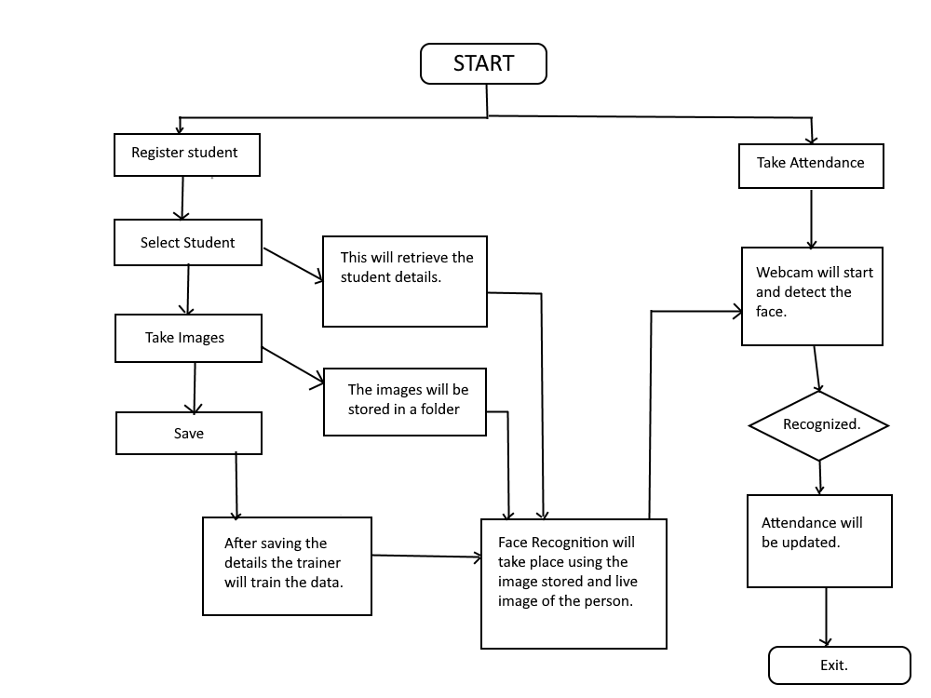

## System Overview

1. User Interface: A user-friendly interface is provided to view and manage the attendance information. This interface allows users to view attendance reports, add/edit student information, and view the attendance history of each student. The interface is built using python tkinter.
2. Data Collection: A dataset of faces of students is collected, consisting of multiple images of each student. These images are then annotated with the student's identity. This dataset is used to train the face recognition model.
3. Model Training: Local Binary Patterns Histograms (LBPH) is a popular and widely used algorithm for face recognition. It is a simple, yet effective, method that captures the texture and local structure of the face images. The model is designed to recognize the faces of students and generate a feature representation for each face. This feature representation is used to identify the students in real-time.
4. Face Detection: The system captures video frames using OpenCV and uses a face detection module, such as Haar cascades or Single Shot MultiBox Detectors (SSD), to detect the faces present in each frame. The face detection module outputs the bounding box for each face detected, which serves as the region of interest (ROI) for the face recognition module.
5. Face Recognition: The system passes the ROI of each detected face to the trained face recognition model. The model generates a feature representation for each face and compares it with the feature representations of the students in the database. The model outputs the identity of the student, if a match is found.
6. Attendance Tracking: The system stores the attendance information in a database, such as SQLite or MySQL. The attendance information includes the date, time, and the identity of each student present in the class. The attendance information is updated in real-time as the faces are recognized.

## Database Design/Data Set Description

For the "Student Management and Attendance System using Face Recognition" project, a database is required to store the information about the students and their attendance. MySQL Workbench is used to manage the data.

Student Information Table: This table stores the basic information about the students, such as their name, student ID, and enrollment date.

Columns:

* Department
* Course
* Year
* Semester
* Name
* Division
* Roll
* Gender
* DOB
* Email
* Phone Number
* Address
* Teacher
* Photo Sample (Yes/No)

## Functional Design

### Describe the functionalities of the system:

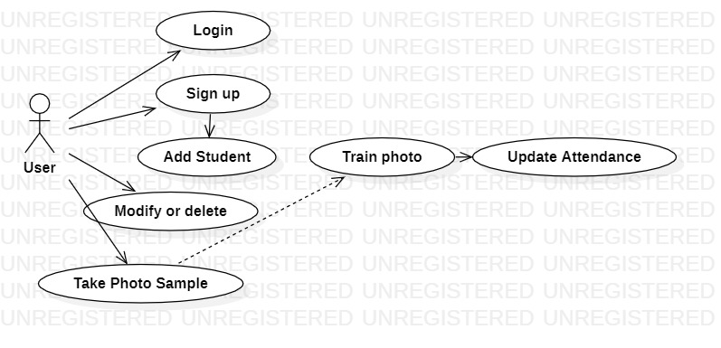

### Login: The user is required to log in to the system using a unique username and password. Upon successful authentication, the user is granted access to the system.

### Register: New users can register for the system by providing their details such as name, username, password, and contact information. The system stores the user information in a secure database for future use.

### Add student: The user can add new students to the system by providing their details such as name, roll number, and contact information. The system stores the student information in a secure database for future use.

### Modify or delete student: The user can modify or delete the information of existing students in the system. This includes the ability to update the student details and to delete the student records entirely.

### Take photo sample: The system provides the facility to take photo samples of the students. The photo samples are stored in the database and used for face recognition during attendance.

1. Train photo sample: The system trains the face recognition model using the photo samples taken for each student. This process involves learning the unique features of each student's face and mapping them to their respective student IDs.
2. Update Attendance: The system uses the face recognition model to identify the students during attendance and updates the attendance records accordingly. The attendance records are stored in the database and can be viewed or modified by the user as required.

### Behavioral design:

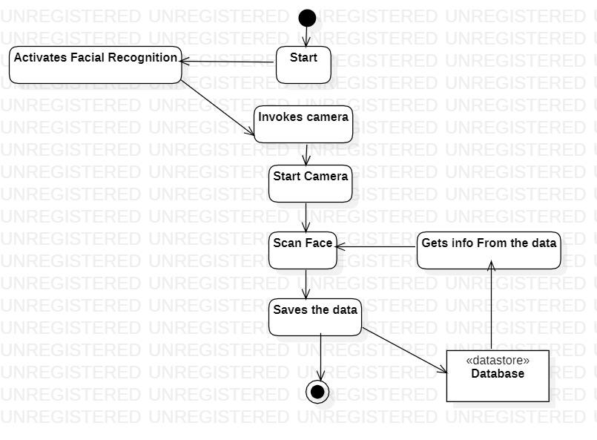

1. Activation of facial recognition: The facial recognition system is activated to begin the process of recognizing student faces.
2. Invocation of the camera: The camera on the device is activated.
3. Start camera: The camera starts capturing images.
4. Scan face: The system scans the faces of students present in the classroom and attempts to match them with the data stored in the database.
5. Saving data: The information obtained from scanning the faces is saved in the database.
6. Database: A database is used to store the information collected during the face recognition process.
7. Get information from the database: The system retrieves information from the database, such as the student's name and attendance status, based on the results of the face recognition process. This information is used to update the student management and attendance records.

# 

# Testing

## Description of Testing

1. Unit Testing:
   * Test the individual components of the system, such as the camera, facial recognition module, database, etc. to ensure they are functioning correctly.
   * Test the data input and output of each component to make sure the correct data is being saved and retrieved.
2. Integration Testing:
   * Test the interaction between components to ensure they are communicating correctly and functioning together as a system.
   * Test the flow of data between components, including the camera, facial recognition module, database, etc.
3. System Testing:
   * Test the entire system, including the user interface, to ensure it is working as intended.
   * Test the facial recognition functionality to ensure it is accurately identifying faces and saving the data correctly.
   * Test the database functionality to ensure it is storing and retrieving the data correctly.

## Test Cases

|  |  |  |  |  |  |  |
| --- | --- | --- | --- | --- | --- | --- |
| **Test case #**  1 | **Test case Name**  Test Camera Functionality | **Test case Description**  Verify if the camera starts and displays live video feed | **Inputs**  Start camera | **Expected Output**  Camera starts and displays live video feed | **Actual Output**  Camera starts and captures photo/video | **Status**  Pass |
| 2 | Test Facial Recognition | Verify if the system correctly recognizes student's face and matches it with the database | Scan face of a student | System correctly recognizes student's face and matches it with the database | System correctly recognizes student's face and matches it with the database | Pass |
| 3 | Test Database Functionality | Verify if the system correctly adds new student's information to the database | Add a new student/Update/ Delete | System correctly adds new student's information to the database | System correctly adds new student's information to the database | Pass |
| 4 | Test Attendance Tracking | Verify if the system correctly updates the attendance for the student in the database | Mark attendance for a student | System correctly updates the attendance for the student in the database | System correctly updates the attendance for the student in the database | Pass |
| 5 | Verify Reports Generation | Test the functionality of the reports generation process to ensure that it correctly generates and exports the attendance reports for the selected period. | Date range for the attendance report | Successful generation and export of the attendance reports in a specified format (e.g. CSV) | Successful generation and export of the attendance reports in a specified format (e.g. CSV) | Pass |

# Results and Discussion

* **Login Page:**

This is the login page where users can enter their id and password to get access to the application. If users do not have their login credentials they can register as a new user. If users forgot their password then they can go to forgot password to reset their password.

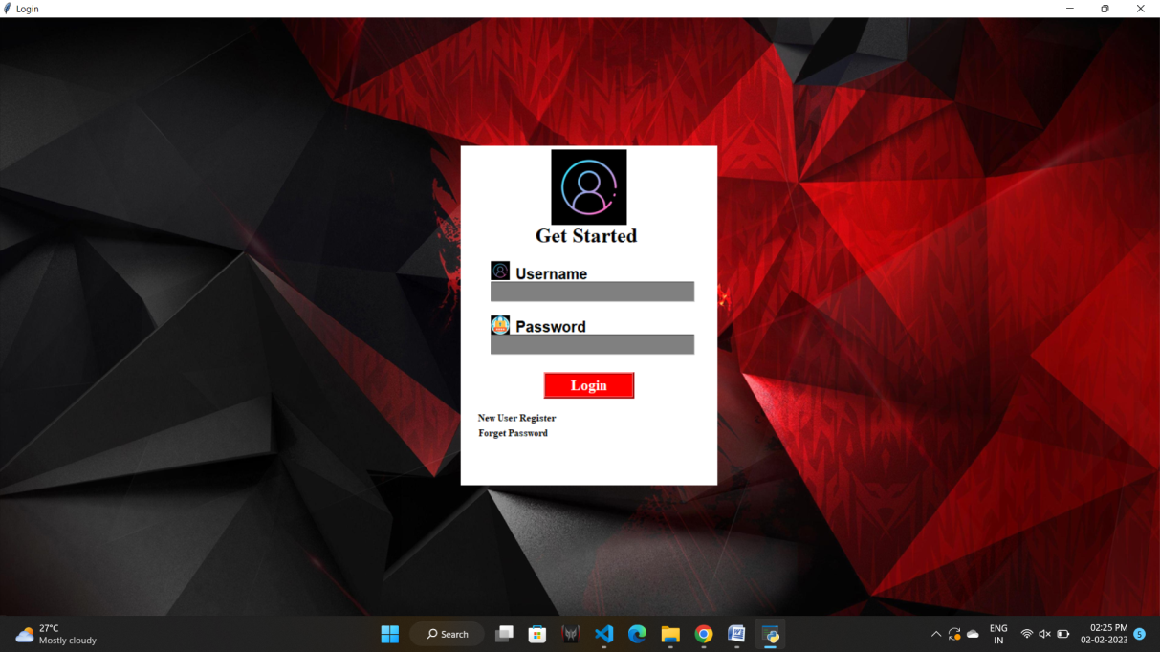

* **Registration Page:**

In this, the users can register to the application by providing the following details as shown in the figure, by registering they can have full access to the application.

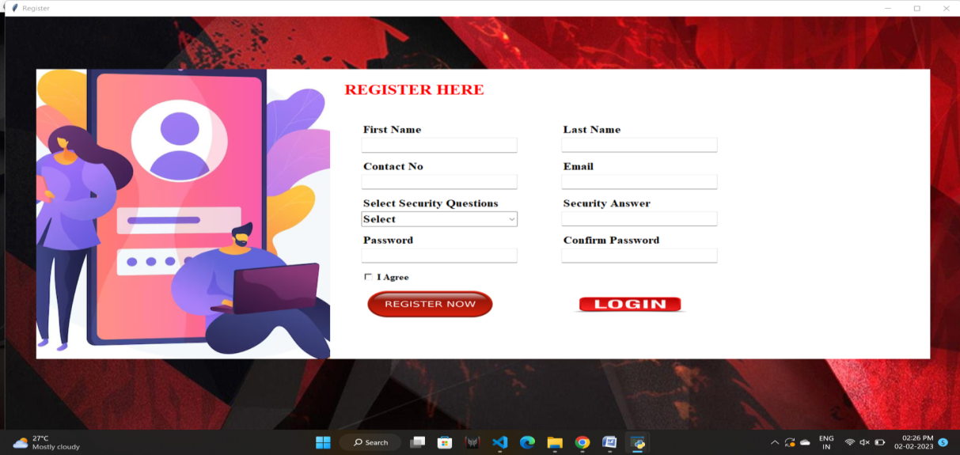

* **Home Page:**

This is the home page and has various functions as such as student as shown in the figure.

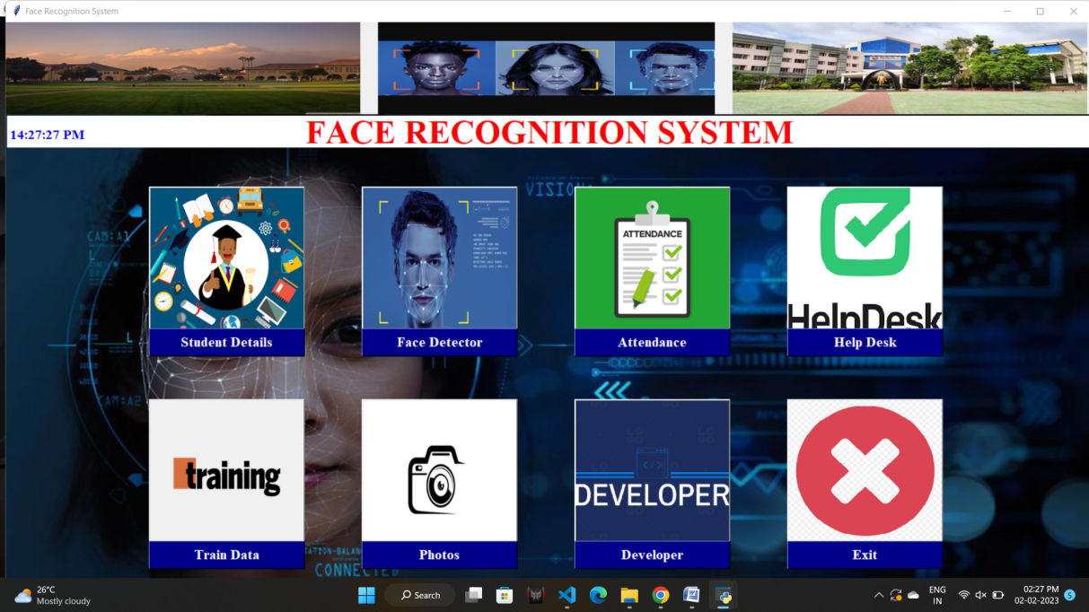

* **Student Details:**

In this page the user can fill up the student details, update them, delete them and take the photo samples accordingly.

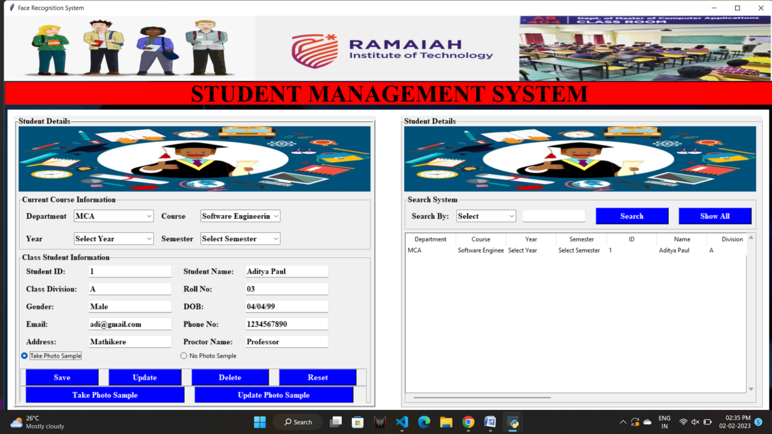

This picture shows how the photo is captured of a student.

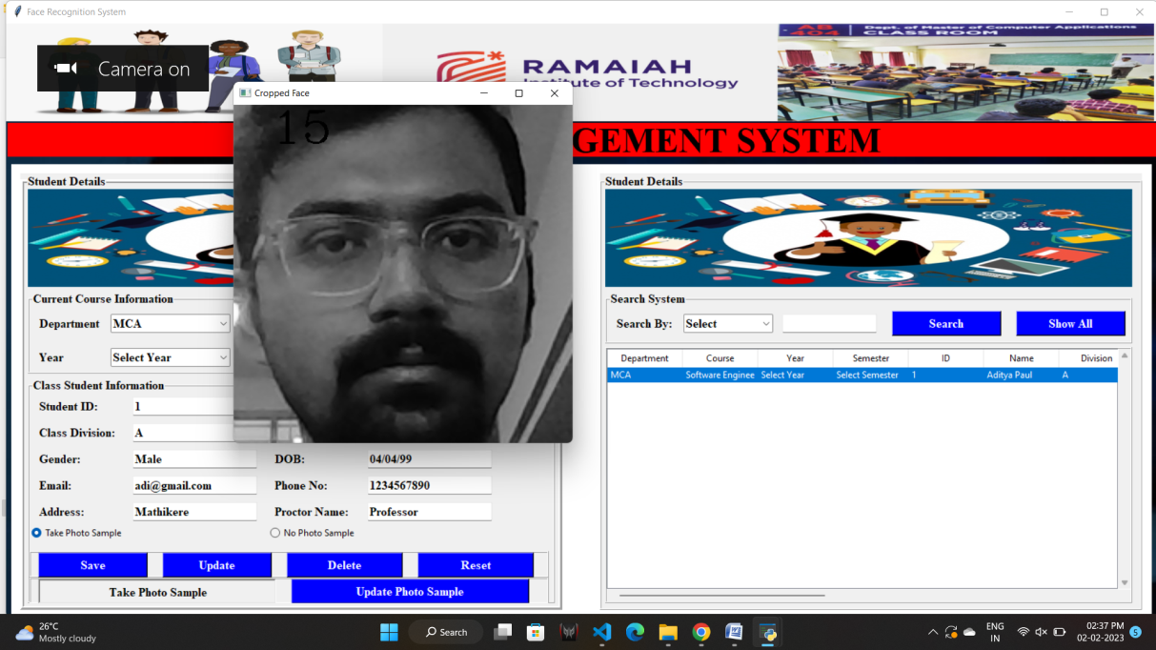

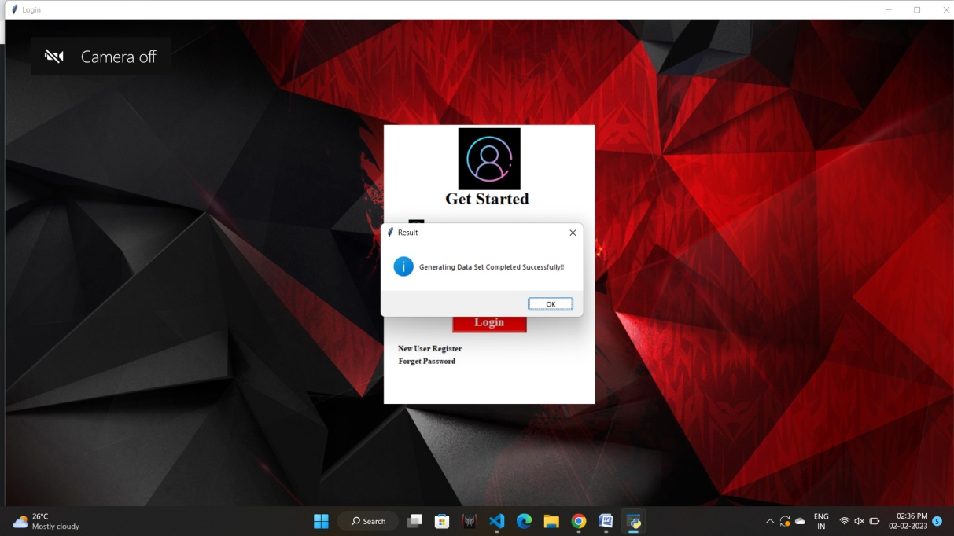

* **Train Dataset:**

The below picture shows the training dataset window, in this the users can train their data generated, here the data is the human face and this is trained using LBHP algorithm.

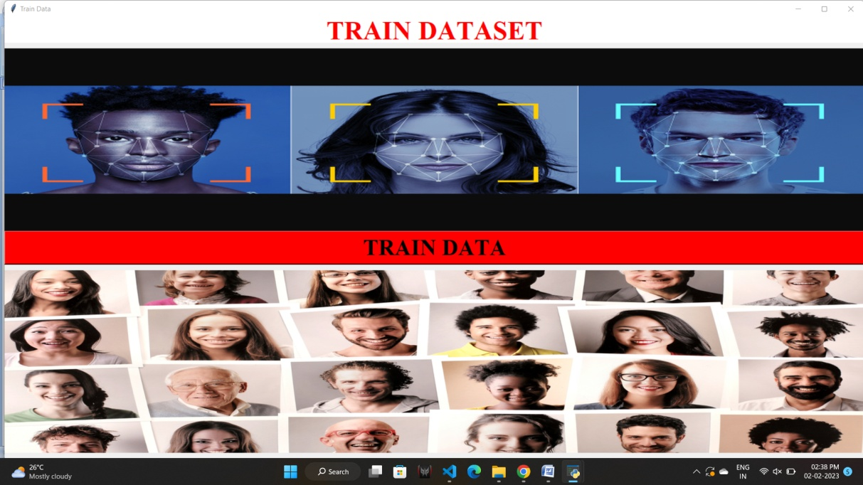

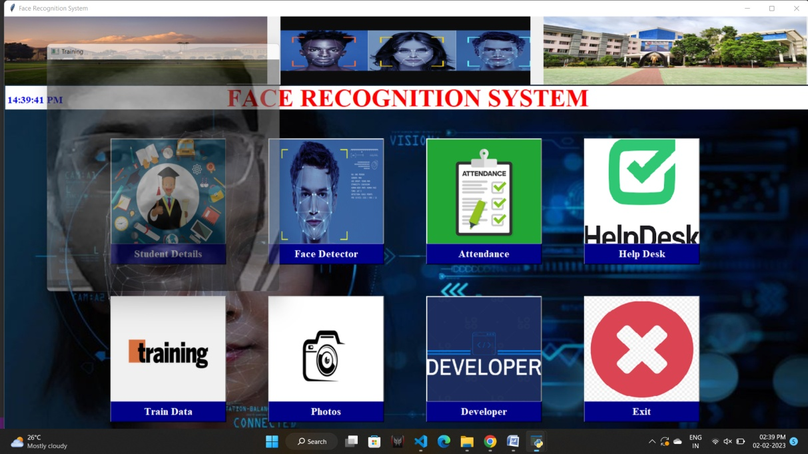

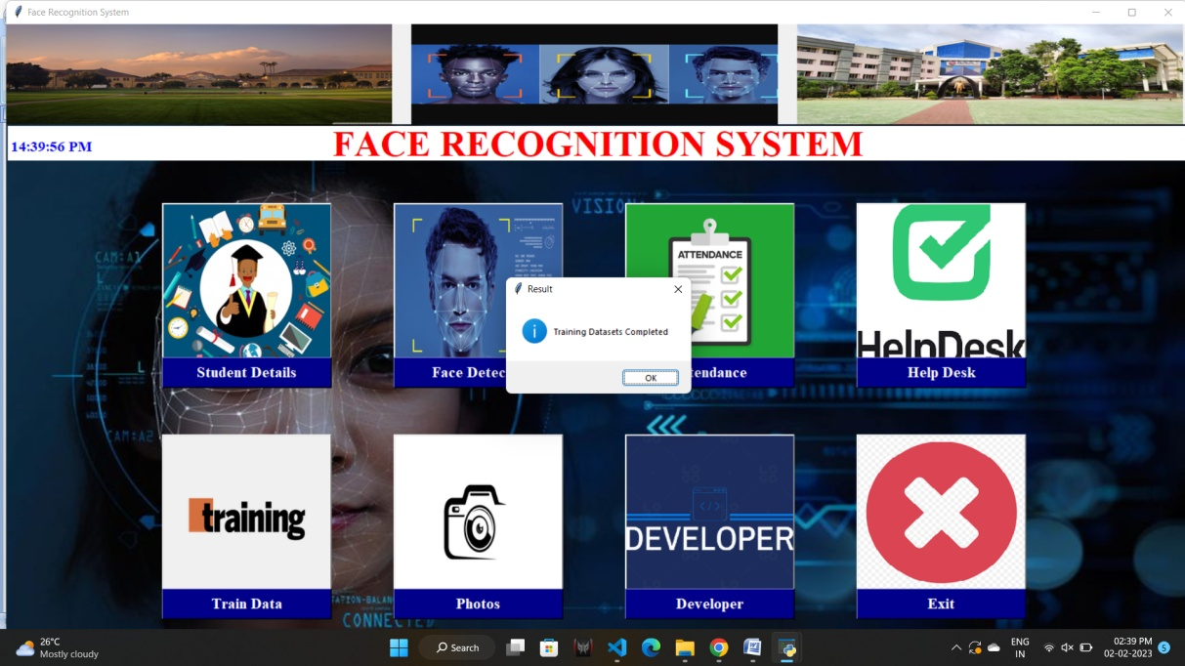

* **Photos:**

This folder shows the dataset generated and trained.

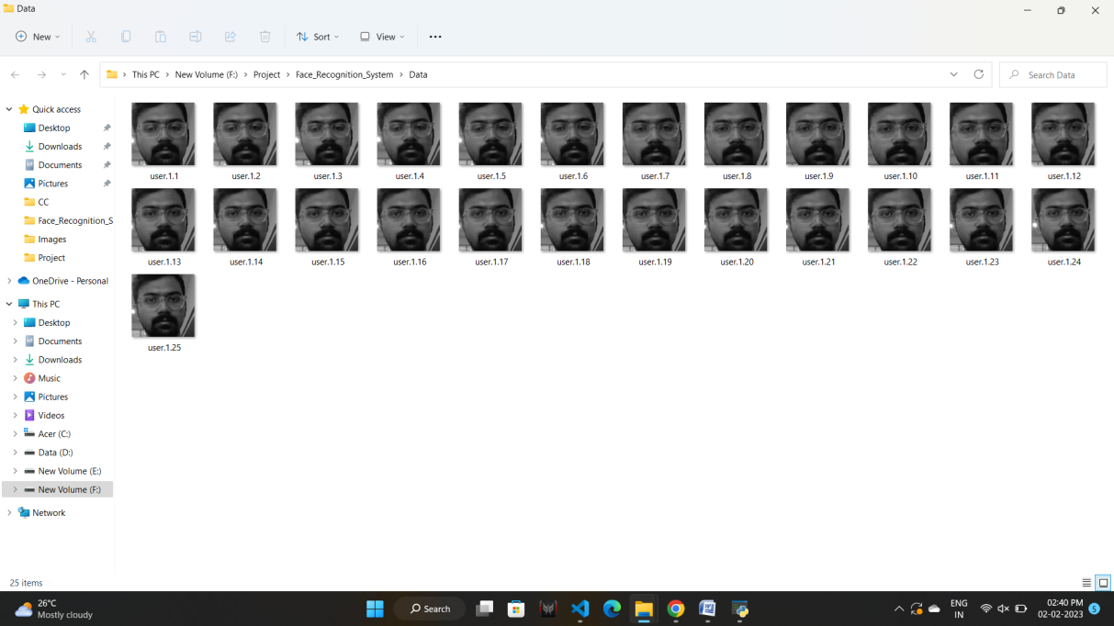

* **Face Recognition:**

This window is used for face recognition, the user can click on the button to recognize the face of the student and then the data will be recorded in a .csv file.

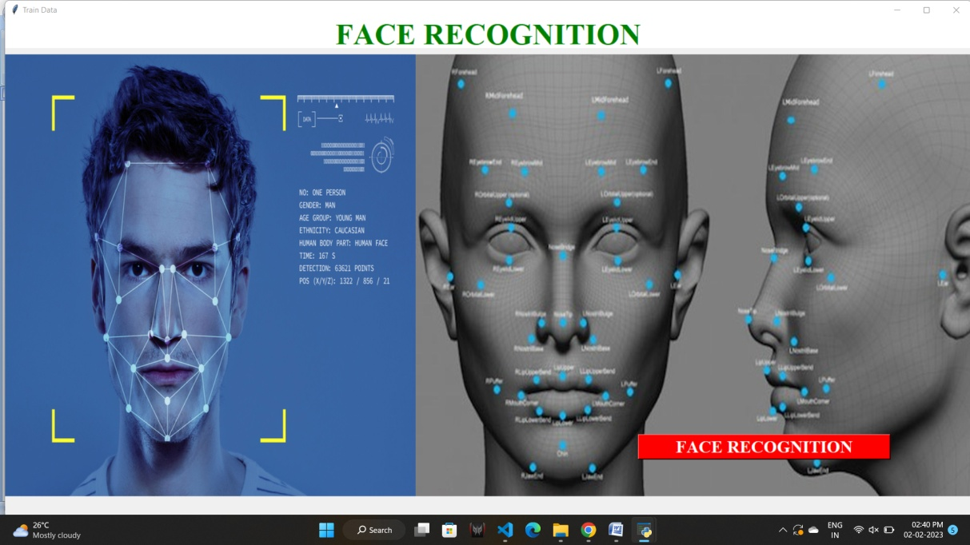

This picture shows the process of face recognising and the result.

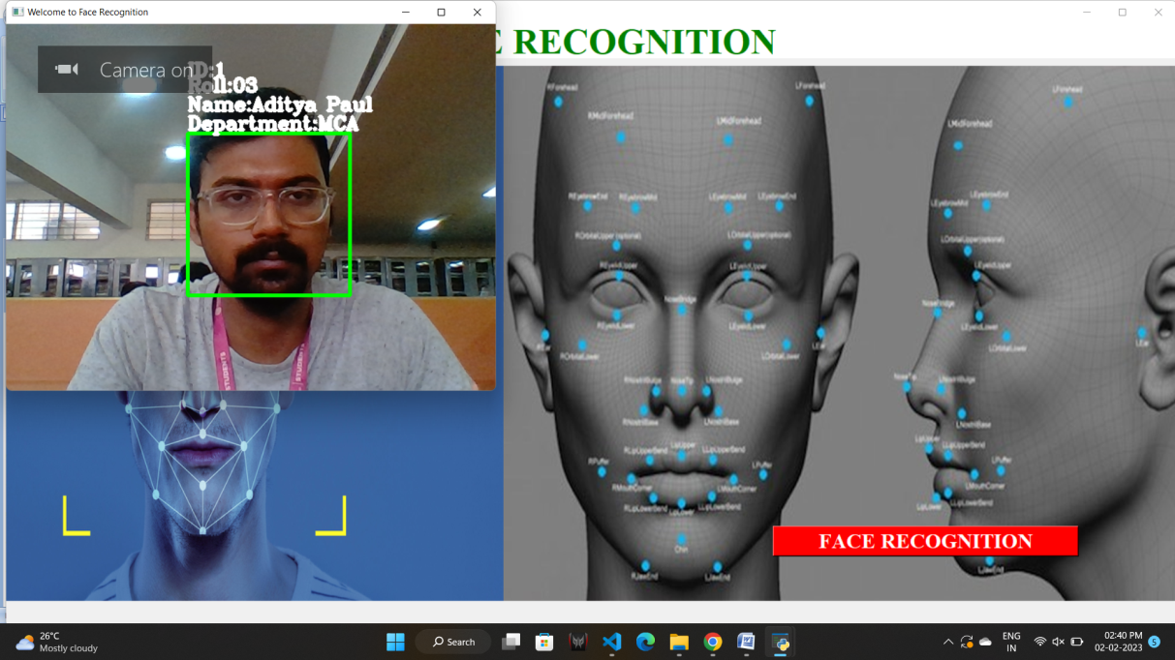

This is the .csv file where the attendance is being recorded as output.



* **Attendance:**

This window displays the attendance in the application itself.

The csv file can be imported here and then updates can be done if needed.

Then if any updates have been made the csv file can be exported as new csv to the system.

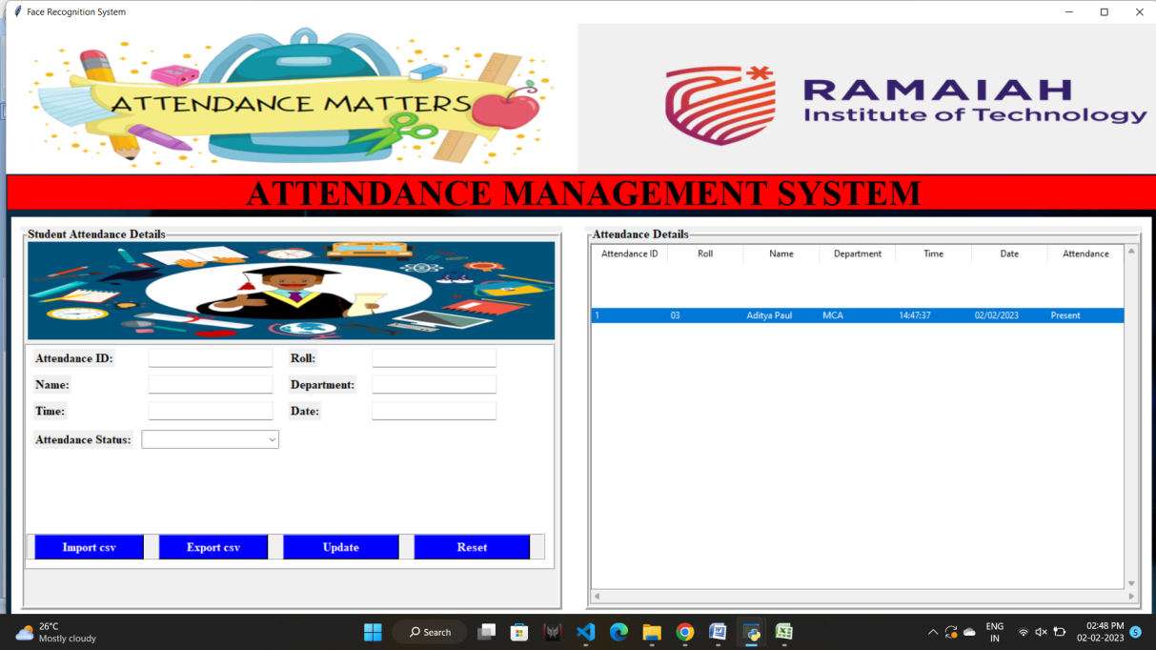

* **Help Desk Window:**

This window displays the email id of the developer, if in case any help needed to anyone.



* **Developer Window:**

This window displays the information of the developer.

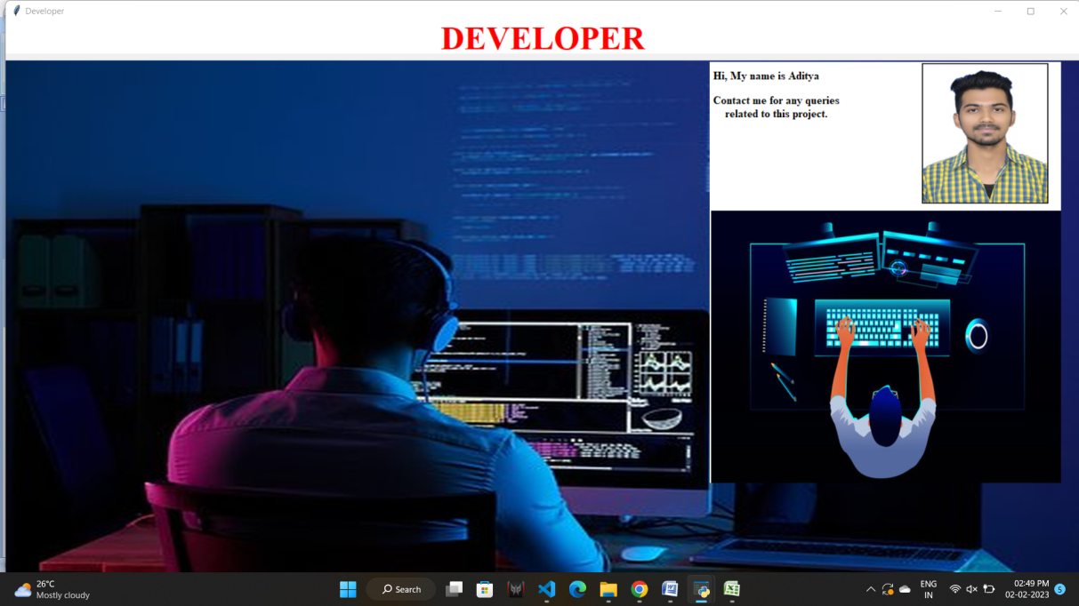

# Conclusion

The "Student management and attendance system using face recognition" project aims to streamline the process of student attendance tracking and management. By utilizing facial recognition technology, the system eliminates the need for manual attendance marking and provides an efficient, accurate, and secure solution. The system's features, such as user management, student management, attendance management, report generation, and security, ensure that the system meets the needs of both teachers and administrators. The implementation of this system has the potential to greatly improve the efficiency and accuracy of student attendance tracking and management, making it a valuable solution for educational institutions. Overall, the "Student management and attendance system using face recognition" project offers a cutting-edge solution for a common problem faced by educational institutions and has the potential to improve the educational experience for both students and teachers.

# Scope for Further Enhancement

The "Student management and attendance system using face recognition" project has great potential for further enhancement and growth. Some potential areas for expansion and improvement include:

Integration with other systems: Integrating the system with other software systems used by the educational institution, such as student information systems or learning management systems, can provide a more seamless and integrated experience for users.

Mobile application: Developing a mobile application that integrates with the system can provide students and teachers with real-time access to attendance information, even when they are not in the classroom.

Attendance tracking for remote learning: Adding support for remote learning, such as tracking attendance for online classes, can ensure that the system remains relevant and useful in today's changing educational landscape.

Improved accuracy and reliability: Improving the accuracy and reliability of the facial recognition technology can further enhance the efficiency and security of the system.

Customizable reports: Providing customizable reporting options for administrators can help them better understand and analyze student attendance data.

Advanced security features: Implementing additional security measures, such as multi-factor authentication, to ensure the privacy and protection of sensitive student data.

# Bibliography

* LBPH OpenCV: https://docs.opencv.org/2.4/modules/contrib/doc/facerec/facerec_tuto rial.html#local-binary-patterns-histograms
* <https://ieeexplore.ieee.org/document/278253>